1. Outlook
   1. Outlook Calendar conditional formatting
      1. View 🡪 View Settings 🡪 Conditional Formatting
   2. Favorites
      1. 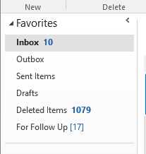
   3. Signature
2. Chrome
   1. Extensions
      1. LastPass
      2. ColorZilla
      3. ServiceNow Utils
   2. Sync disabled
   3. Import bookmarks
3. Word
   1. Save 🡪 Default Location = H:\
4. Excel
   1. Save 🡪 Default Location = H:\
5. Software
   1. Notepad++
   2. Screen shot software
   3. Soft phone
   4. ADExplorer (manual install)
6. Task bar

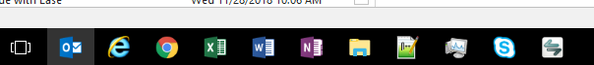

1. Pinned items

